Brandon Mullins

CS-255

Project 2

Southern New Hampshire University

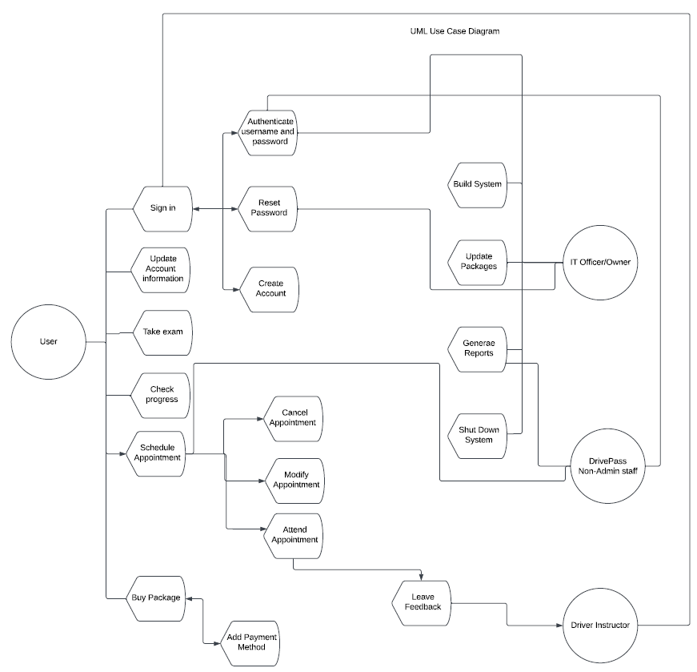

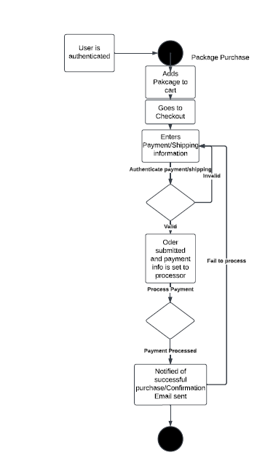

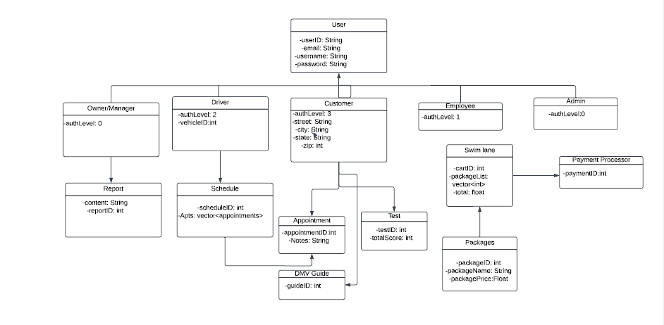

Technical Requirements:

**Hardware Requirements:**

* A dedicated server to hosting the website and database.
* A reliable internet connection to ensure uninterrupted access.
* Sufficient storage capacity to accommodate the database and website data.
* A computer or mobile device for users to access the website.
* A firewall to protect website ports and enhance security.

**Software Requirements:**

* Windows Server for its reliability and stability.
* SQL Server for database management, utilizing the most stable release available.
* Backup software to safeguard both website and database data.
* A web server, such as Apache, to handle website operations.
* Security software to detect and prevent malware threats.

**Geographic Considerations:**

* Ensure website accessibility across the United States.
* Host the website and database server in a secure, well-maintained data center.
* Position the server in a central location to optimize performance and user accessibility.